AIM: To develop a Support Vector Machine (SVM) classification model using Python to predict students' results based on their hours studied, attendance, assignments, and marks, and to evaluate the model using accuracy, a confusion matrix, and a classification report.

ALGORITHM:
1. Start
2. Import the required Python libraries: Pandas and Scikit-learn.
3. Load the student dataset from data.csv.
4. Remove unnecessary spaces from the column names.
5. Select the input features: Hours studied, Attendance, Assignment, and Marks.
6. Select Result as the target variable.
7. Check whether the target variable contains at least two different classes.
8. If only one class is present, display a message indicating that more data is required.
9. If multiple classes are present, split the dataset into training data (80%) and testing data (20%).
10. Create an SVM classifier using a linear kernel.
11.Train the model using the training dataset.
12.Predict student results using the testing dataset.
13.Evaluate the model using accuracy, a confusion matrix, and a classification report.
14.Stop
OUTPUT:
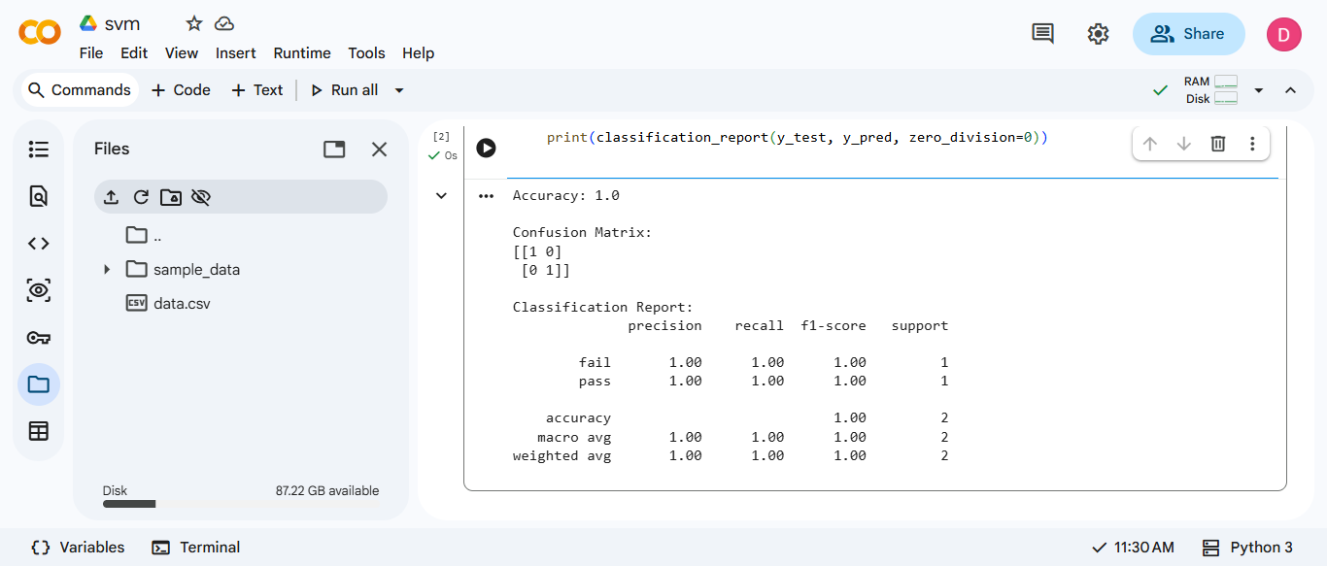

RESULT: Thus, the Support Vector Machine (SVM) classification program was implemented successfully using Python. The dataset was analyzed, and it was found that all 9 student records belong to the pass class. Therefore, additional data containing both pass and fail results is required to train and evaluate the classification model effectively.

